**Data Cleaning**

**Import libraries**

In [2]:

**import** numpy **as** np

**import** pandas **as** pd

**import** matplotlib.pyplot **as** plt

**import** seaborn **as** sns

**Load and Read Dataset**

In [21]:

data **=** pd**.**read_csv('weatherHistory.csv')

data**.**head()

Out[21]:

|  | **Formatted Date** | **Summary** | **Precip Type** | **Temperature (C)** | **Apparent Temperature (C)** | **Humidity** | **Wind Speed (km/h)** | **Wind Bearing (degrees)** | **Visibility (km)** | **Loud Cover** | **Pressure (millibars)** | **Daily Summary** |
| --- | --- | --- | --- | --- | --- | --- | --- | --- | --- | --- | --- | --- |
| **0** | 2006-04-01 00:00:00.000 +0200 | Partly Cloudy | rain | 9.472222 | 7.388889 | 0.89 | 14.1197 | 251.0 | 15.8263 | 0.0 | 1015.13 | Partly cloudy throughout the day. |
| **1** | 2006-04-01 01:00:00.000 +0200 | Partly Cloudy | rain | 9.355556 | 7.227778 | 0.86 | 14.2646 | 259.0 | 15.8263 | 0.0 | 1015.63 | Partly cloudy throughout the day. |
| **2** | 2006-04-01 02:00:00.000 +0200 | Mostly Cloudy | rain | 9.377778 | 9.377778 | 0.89 | 3.9284 | 204.0 | 14.9569 | 0.0 | 1015.94 | Partly cloudy throughout the day. |
| **3** | 2006-04-01 03:00:00.000 +0200 | Partly Cloudy | rain | 8.288889 | 5.944444 | 0.83 | 14.1036 | 269.0 | 15.8263 | 0.0 | 1016.41 | Partly cloudy throughout the day. |
| **4** | 2006-04-01 04:00:00.000 +0200 | Mostly Cloudy | rain | 8.755556 | 6.977778 | 0.83 | 11.0446 | 259.0 | 15.8263 | 0.0 | 1016.51 | Partly cloudy throughout the day. |

**Dimensions of the dataframe**

In [36]:

data**.**shape

Out[36]:

(96453, 12)

**Datatypes of the dataframe**

In [4]:

data**.**info()

RangeIndex: 96453 entries, 0 to 96452

Data columns (total 12 columns):

# Column Non-Null Count Dtype

--- ------ -------------- -----

0 Formatted Date 96453 non-null object

1 Summary 96453 non-null object

2 Precip Type 95936 non-null object

3 Temperature (C) 96453 non-null float64

4 Apparent Temperature (C) 96453 non-null float64

5 Humidity 96453 non-null float64

6 Wind Speed (km/h) 96453 non-null float64

7 Wind Bearing (degrees) 96453 non-null float64

8 Visibility (km) 96453 non-null float64

9 Loud Cover 96453 non-null float64

10 Pressure (millibars) 96453 non-null float64

11 Daily Summary 96453 non-null object

dtypes: float64(8), object(4)

memory usage: 8.8+ MB

**Statistical details of the dataframe**

In [5]:

data**.**describe()

Out[5]:

|  | **Temperature (C)** | **Apparent Temperature (C)** | **Humidity** | **Wind Speed (km/h)** | **Wind Bearing (degrees)** | **Visibility (km)** | **Loud Cover** | **Pressure (millibars)** |
| --- | --- | --- | --- | --- | --- | --- | --- | --- |
| **count** | 96453.000000 | 96453.000000 | 96453.000000 | 96453.000000 | 96453.000000 | 96453.000000 | 96453.0 | 96453.000000 |
| **mean** | 11.932678 | 10.855029 | 0.734899 | 10.810640 | 187.509232 | 10.347325 | 0.0 | 1003.235956 |
| **std** | 9.551546 | 10.696847 | 0.195473 | 6.913571 | 107.383428 | 4.192123 | 0.0 | 116.969906 |
| **min** | -21.822222 | -27.716667 | 0.000000 | 0.000000 | 0.000000 | 0.000000 | 0.0 | 0.000000 |
| **25%** | 4.688889 | 2.311111 | 0.600000 | 5.828200 | 116.000000 | 8.339800 | 0.0 | 1011.900000 |
| **50%** | 12.000000 | 12.000000 | 0.780000 | 9.965900 | 180.000000 | 10.046400 | 0.0 | 1016.450000 |
| **75%** | 18.838889 | 18.838889 | 0.890000 | 14.135800 | 290.000000 | 14.812000 | 0.0 | 1021.090000 |
| **max** | 39.905556 | 39.344444 | 1.000000 | 63.852600 | 359.000000 | 16.100000 | 0.0 | 1046.380000 |

**Handling missing values**

In [6]:

*#Check for missing values*

data**.**isnull()**.**sum()

Out[6]:

Formatted Date 0

Summary 0

Precip Type 517

Temperature (C) 0

Apparent Temperature (C) 0

Humidity 0

Wind Speed (km/h) 0

Wind Bearing (degrees) 0

Visibility (km) 0

Loud Cover 0

Pressure (millibars) 0

Daily Summary 0

dtype: int64

**Dataframe columns**

We only need 3 columns for our task which is data['Formatted Date','Apperent Temperature(c)','Humidity']

In [7]:

data**.**columns

Out[7]:

Index(['Formatted Date', 'Summary', 'Precip Type', 'Temperature (C)',

'Apparent Temperature (C)', 'Humidity', 'Wind Speed (km/h)',

'Wind Bearing (degrees)', 'Visibility (km)', 'Loud Cover',

'Pressure (millibars)', 'Daily Summary'],

dtype='object')

Observation:

1. In 'Precip Type', there are 517 missing values.
2. 'Wind Bearing (degrees)' has only integer values and Formatted Date is in String.
3. Minimum values of Humidity, Wind Speed (km/h), Wind Bearing (degrees), Visibility (km) are Zero and they can be Zero.

**Drop unwanted columns**

In [8]:

data['Loud Cover']**.**unique()

Out[8]:

array([0.])

In [9]:

data **=** data**.**drop(['Loud Cover'], axis **=** 1)

In [11]:

plt**.**figure(figsize**=**(10,8))

sns**.**heatmap(data**=** data**.**corr(), annot**=True**)

plt**.**title("Pairwise correlation of all columns in the dataframe")

*# save the figure*

plt**.**savefig('plot6.png', dpi**=**300, bbox_inches**=**'tight')

plt**.**show()

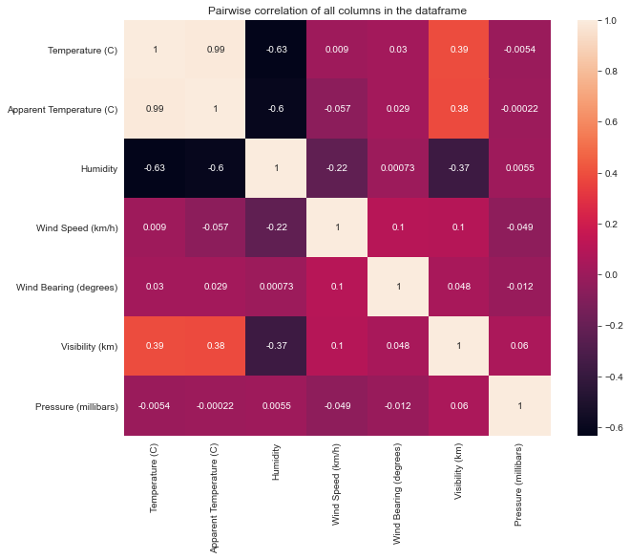

**Changing Formatted Date from String to Datetime**

In [12]:

data['Formatted Date'] **=** pd**.**to_datetime(data['Formatted Date'], utc**=True**)

In [13]:

data**.**info()

RangeIndex: 96453 entries, 0 to 96452

Data columns (total 11 columns):

# Column Non-Null Count Dtype

--- ------ -------------- -----

0 Formatted Date 96453 non-null datetime64[ns, UTC]

1 Summary 96453 non-null object

2 Precip Type 95936 non-null object

3 Temperature (C) 96453 non-null float64

4 Apparent Temperature (C) 96453 non-null float64

5 Humidity 96453 non-null float64

6 Wind Speed (km/h) 96453 non-null float64

7 Wind Bearing (degrees) 96453 non-null float64

8 Visibility (km) 96453 non-null float64

9 Pressure (millibars) 96453 non-null float64

10 Daily Summary 96453 non-null object

dtypes: datetime64[ns, UTC](1), float64(7), object(3)

memory usage: 8.1+ MB

**Number of Distinct Observation**

In [20]:

data**.**nunique()

Out[20]:

Summary 27

Precip Type 2

Temperature (C) 7574

Apparent Temperature (C) 8984

Humidity 90

Wind Speed (km/h) 2484

Wind Bearing (degrees) 360

Visibility (km) 949

Pressure (millibars) 4979

Daily Summary 214

dtype: int64

In [15]:

data **=** data**.**set_index("Formatted Date")

data

Out[15]:

|  | **Summary** | **Precip Type** | **Temperature (C)** | **Apparent Temperature (C)** | **Humidity** | **Wind Speed (km/h)** | **Wind Bearing (degrees)** | **Visibility (km)** | **Pressure (millibars)** | **Daily Summary** |
| --- | --- | --- | --- | --- | --- | --- | --- | --- | --- | --- |
| **Formatted Date** |  |  |  |  |  |  |  |  |  |  |
| **2006-03-31 22:00:00+00:00** | Partly Cloudy | rain | 9.472222 | 7.388889 | 0.89 | 14.1197 | 251.0 | 15.8263 | 1015.13 | Partly cloudy throughout the day. |
| **2006-03-31 23:00:00+00:00** | Partly Cloudy | rain | 9.355556 | 7.227778 | 0.86 | 14.2646 | 259.0 | 15.8263 | 1015.63 | Partly cloudy throughout the day. |
| **2006-04-01 00:00:00+00:00** | Mostly Cloudy | rain | 9.377778 | 9.377778 | 0.89 | 3.9284 | 204.0 | 14.9569 | 1015.94 | Partly cloudy throughout the day. |
| **2006-04-01 01:00:00+00:00** | Partly Cloudy | rain | 8.288889 | 5.944444 | 0.83 | 14.1036 | 269.0 | 15.8263 | 1016.41 | Partly cloudy throughout the day. |
| **2006-04-01 02:00:00+00:00** | Mostly Cloudy | rain | 8.755556 | 6.977778 | 0.83 | 11.0446 | 259.0 | 15.8263 | 1016.51 | Partly cloudy throughout the day. |
| **...** | ... | ... | ... | ... | ... | ... | ... | ... | ... | ... |
| **2016-09-09 17:00:00+00:00** | Partly Cloudy | rain | 26.016667 | 26.016667 | 0.43 | 10.9963 | 31.0 | 16.1000 | 1014.36 | Partly cloudy starting in the morning. |
| **2016-09-09 18:00:00+00:00** | Partly Cloudy | rain | 24.583333 | 24.583333 | 0.48 | 10.0947 | 20.0 | 15.5526 | 1015.16 | Partly cloudy starting in the morning. |
| **2016-09-09 19:00:00+00:00** | Partly Cloudy | rain | 22.038889 | 22.038889 | 0.56 | 8.9838 | 30.0 | 16.1000 | 1015.66 | Partly cloudy starting in the morning. |
| **2016-09-09 20:00:00+00:00** | Partly Cloudy | rain | 21.522222 | 21.522222 | 0.60 | 10.5294 | 20.0 | 16.1000 | 1015.95 | Partly cloudy starting in the morning. |
| **2016-09-09 21:00:00+00:00** | Partly Cloudy | rain | 20.438889 | 20.438889 | 0.61 | 5.8765 | 39.0 | 15.5204 | 1016.16 | Partly cloudy starting in the morning. |

96453 rows × 10 columns

* Now, we have hourly data, we need to resample it to monthly.
* Resampling is a convenient method for frequency conversion.Object must have a datetime like index

**By Resampling, Create new DataFrame only for Apparent Temperature and Humidity**

In [16]:

df_column **=** ['Apparent Temperature (C)', 'Humidity']

df_monthly_mean **=** data[df_column]**.**resample("MS")**.**mean() *#MS-Month Starting*

df_monthly_mean**.**head()

Out[16]:

|  | **Apparent Temperature (C)** | **Humidity** |
| --- | --- | --- |
| **Formatted Date** |  |  |
| **2005-12-01 00:00:00+00:00** | -4.050000 | 0.890000 |
| **2006-01-01 00:00:00+00:00** | -4.173708 | 0.834610 |
| **2006-02-01 00:00:00+00:00** | -2.990716 | 0.843467 |
| **2006-03-01 00:00:00+00:00** | 1.969780 | 0.778737 |
| **2006-04-01 00:00:00+00:00** | 12.098827 | 0.728625 |

"MS" denotes Month starting.We are displaying the average apparent temperature and humidity using mean() function.

**Exploratory Data Analysis**

Given:

The Null Hypothesis H0 is "Has the Apparent temperature and humidity compared monthly across 10 years of the data indicate an increase due to Global warming".

The Alternative Hypothesis H1 is "Has the Apparent temperature and humidity compared monthly across 10 years of the data not indicate an increase due to Global warming".

In [18]:

sns**.**set_style("darkgrid")

sns**.**regplot(data**=**df_monthly_mean, x**=**"Apparent Temperature (C)", y**=**"Humidity", color**=**"g")

plt**.**title("Relation between Apparent Temperature (C) and Humidity")

*# save the figure*

plt**.**savefig('plot1.png', dpi**=**300, bbox_inches**=**'tight')

plt**.**show()

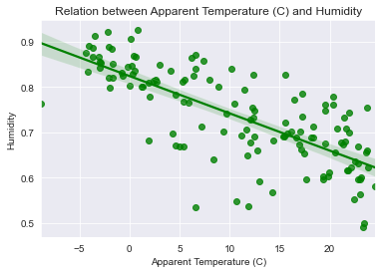

Observation: There might be Linear Relationship between "Apparent Temperature (C)" and "Humidity" with negative slope.

In [19]:

plt**.**figure(figsize**=**(14,6))

sns**.**lineplot(data **=** df_monthly_mean)

plt**.**xlabel('Year')

plt**.**title("Variation of Apparent Temperature and Humidity with time")

*# save the figure*

plt**.**savefig('plot2.png', dpi**=**300, bbox_inches**=**'tight')

plt**.**show()

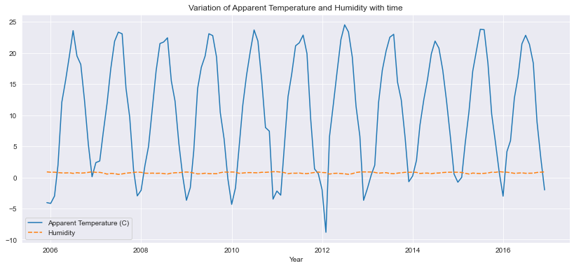

**Observation:**

From the above plot,

1. "Humidity" remained constant from 2006 - 2016
2. "Apparent Temperature (C)" frequently changed from 2006 - 2016

**Pair plot for correlation of Apparent temperature & Humidity**

In [73]:

*# Pair plot for correlation of Apparent temperature & Humidity*

sns**.**set_style("darkgrid")

plt**.**figure(figsize**=**(4,4))

plt**.**title("Correlation between Apparent temperature & Humidity")

sns**.**heatmap(data**=** df_monthly_mean**.**corr(), annot**=True**)

*# save the figure*

plt**.**savefig('plot7.png', dpi**=**300, bbox_inches**=**'tight')

plt**.**show()

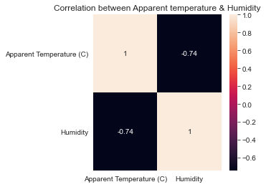

In [81]:

sns**.**pairplot(df_monthly_mean, kind**=**'scatter')

*# save the figure*

plt**.**savefig('plot8.png', dpi**=**300, bbox_inches**=**'tight')

plt**.**show()

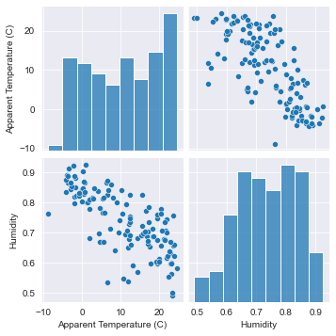

**2D Scatter Plot with Color Coding for each Summary type**

In [48]:

sns**.**set_style("darkgrid")

sns**.**FacetGrid(data, hue**=**"Summary", height**=**10)**.**map(plt**.**scatter, "Apparent Temperature (C)", "Humidity")**.**add_legend()

plt**.**title("2D Scatter Plot with Color Coding for each Summary type")

*# save the figure*

plt**.**savefig('plot3.png', dpi**=**300, bbox_inches**=**'tight')

plt**.**show()

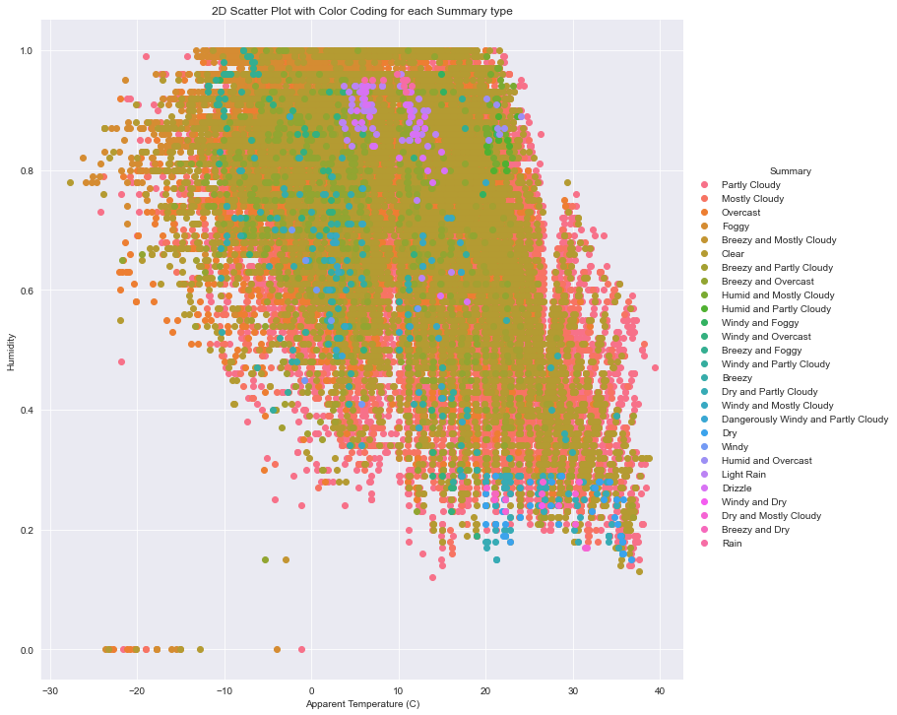

Observation:

1. There are very few outlier.
2. Mostly Weather is Clear or Partly Cloudy/Rain in Finland.
3. Only few days there has a Light Rain or Dry or Dangerously Windy and Partly Cloudy.

**Univariate Analysis**

In [50]:

*# For Apparent Temperature (C)*

sns**.**set_style("darkgrid")

sns**.**FacetGrid(data, hue**=**"Summary", height**=**10)**.**map(sns**.**histplot, "Apparent Temperature (C)")**.**add_legend()

plt**.**title("Analysis of Weather Conditions with Apparent Temperature")

*# save the figure*

plt**.**savefig('plot4.png', dpi**=**300, bbox_inches**=**'tight')

plt**.**show()

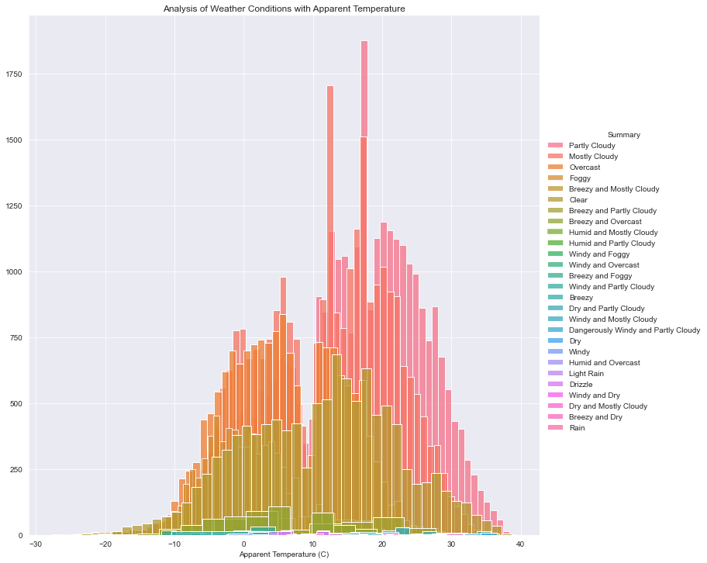

In [51]:

*# For Humidity*

sns**.**set_style("darkgrid")

sns**.**FacetGrid(data, hue**=**"Summary",height**=**10)**.**map(sns**.**histplot, "Humidity")**.**add_legend()

plt**.**title("Analysis of Weather Conditions with Humidity")

*# save the figure*

plt**.**savefig('plot5.png', dpi**=**300, bbox_inches**=**'tight')

plt**.**show()

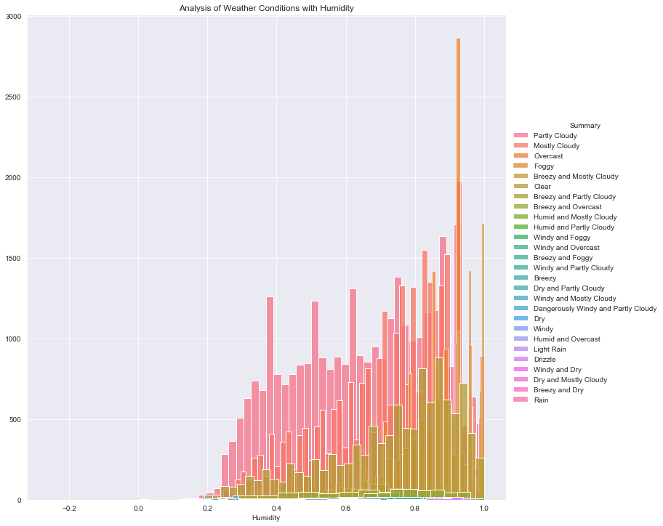

Observation: "Humidity" is better Feature than "Apparent Temperature (C)"

**Function for plotting Humidity & Apparent Temperature for all months**

In [24]:

*# Function for plotting Humidity & Apparent Temperature for all month*

TEMP_DATA **=** df_monthly_mean**.**iloc[:,0]

HUM_DATA **=** df_monthly_mean**.**iloc[:,1]

**def** label_color(month):

**if** month **==** 1:

**return** 'January','blue'

**elif** month **==** 2:

**return** 'February','green'

**elif** month **==** 3:

**return** 'March','orange'

**elif** month **==** 4:

**return** 'April','yellow'

**elif** month **==** 5:

**return** 'May','red'

**elif** month **==** 6:

**return** 'June','violet'

**elif** month **==** 7:

**return** 'July','purple'

**elif** month **==** 8:

**return** 'August','black'

**elif** month **==** 9:

**return** 'September','brown'

**elif** month **==** 10:

**return** 'October','darkblue'

**elif** month **==** 11:

**return** 'November','grey'

**else**:

**return** 'December','pink'

**def** plot_month(month, data):

label, color **=** label_color(month)

mdata **=** data[data**.**index**.**month **==** month]

sns**.**lineplot(data**=**mdata,label**=**label,color**=**color,marker**=**'o')

**def** sns_plot(title, data):

plt**.**figure(figsize**=**(14,8))

plt**.**title(title)

plt**.**xlabel('YEAR')

**for** i **in** range(1,13):

plot_month(i,data)

plt**.**savefig('plot10.png', dpi**=**300, bbox_inches**=**'tight')

*#plt.savefig('plot11.png', dpi=300, bbox_inches='tight')*

plt**.**show()

In [23]:

*# Month-wise Plot for Apparent Temperature of 10 years*

title **=** 'Month-wise Plot for Apparent Temperature of 10 years'

sns_plot(title, TEMP_DATA)

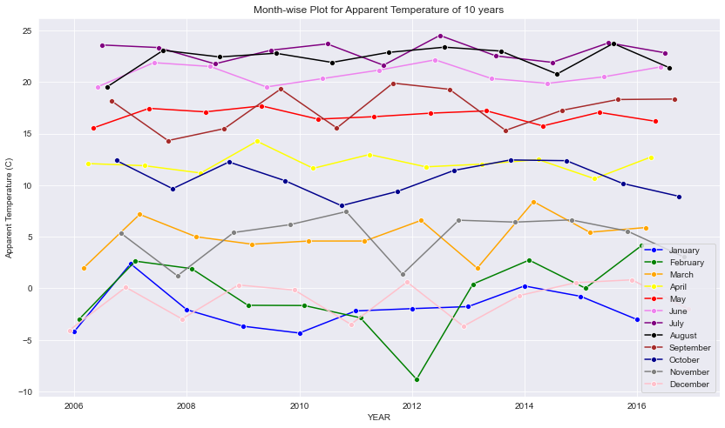

In [25]:

*# Month-wise Plot for Humidity of 10 years*

title **=** 'Month-wise Plot for Humidity of 10 years'

sns_plot(title, HUM_DATA)

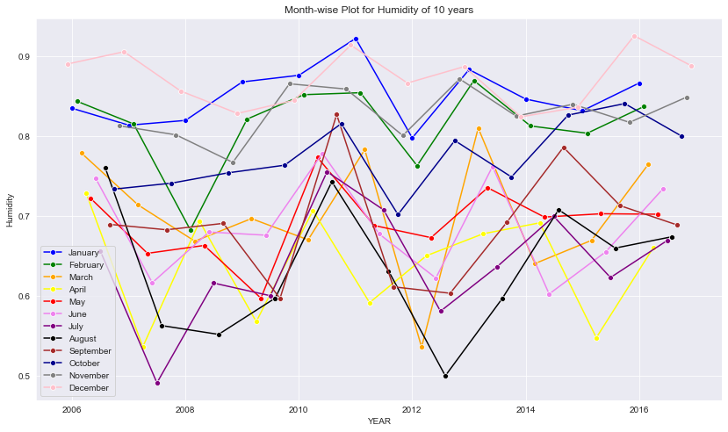

In [121]:

*# Function for plotting Apparent Temperature & Humidity for each month*

**def** sns_month_plot(month):

plt**.**figure(figsize**=**(10,5))

label **=** label_color(month)[0]

plt**.**title('Apparent Temperature Vs Humidity for {}'**.**format(label))

plt**.**xlabel('YEAR')

data **=** df_monthly_mean[df_monthly_mean**.**index**.**month **==** month]

sns**.**lineplot(data**=**data, marker**=**'o')

name**=**"month"**+**str(month)**+**".png"

plt**.**savefig(name, dpi**=**300, bbox_inches**=**'tight')

plt**.**show()

print('-'**\***80)

In [122]:

*# plot for the month of JANUARY - DECEMBER*

**for** month **in** range(1,13):

sns_month_plot(month)

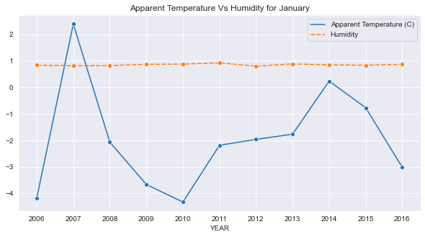

--------------------------------------------------------------------------------

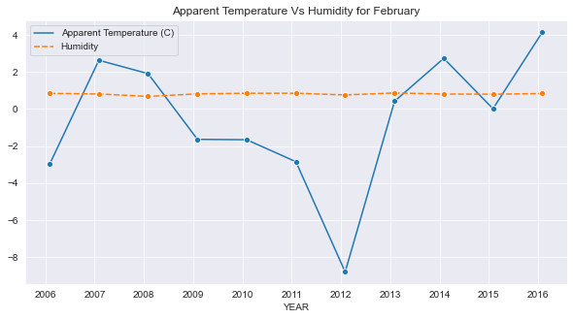

--------------------------------------------------------------------------------

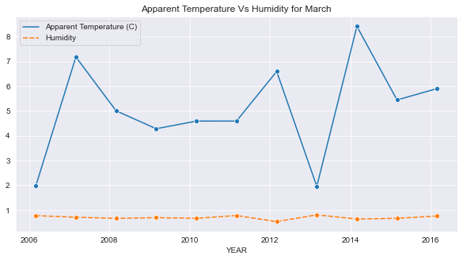

--------------------------------------------------------------------------------

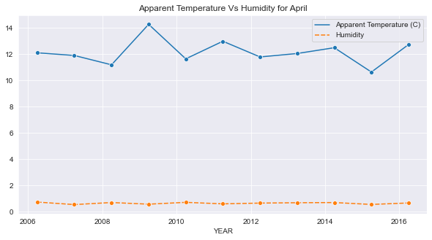

--------------------------------------------------------------------------------

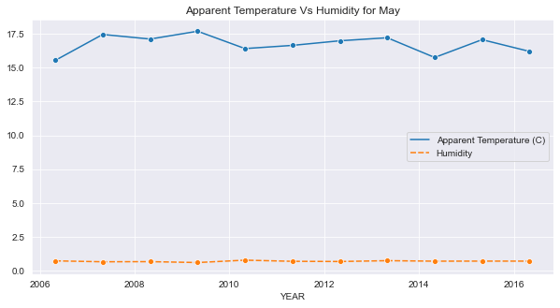

--------------------------------------------------------------------------------

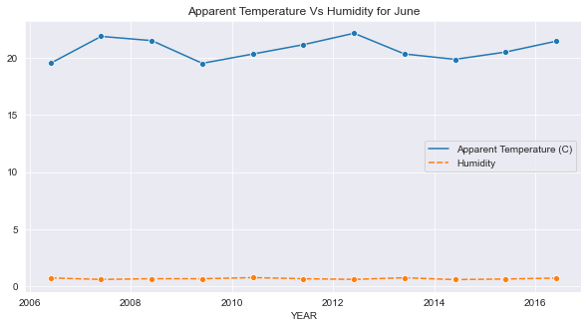

--------------------------------------------------------------------------------

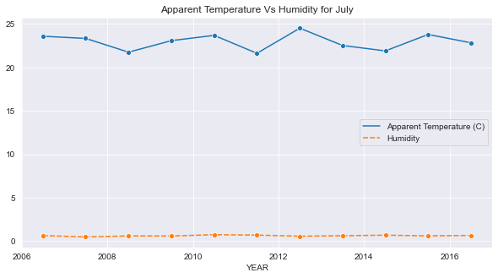

--------------------------------------------------------------------------------

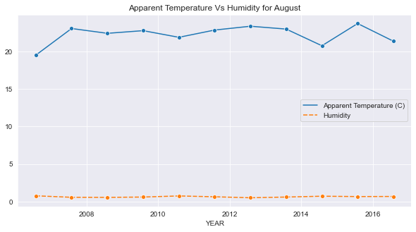

--------------------------------------------------------------------------------

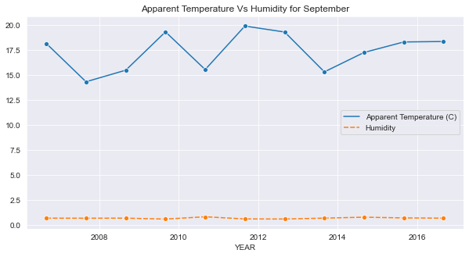

--------------------------------------------------------------------------------

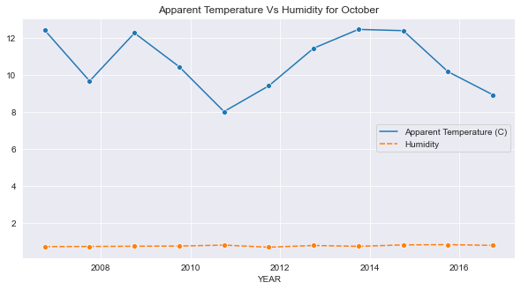

--------------------------------------------------------------------------------

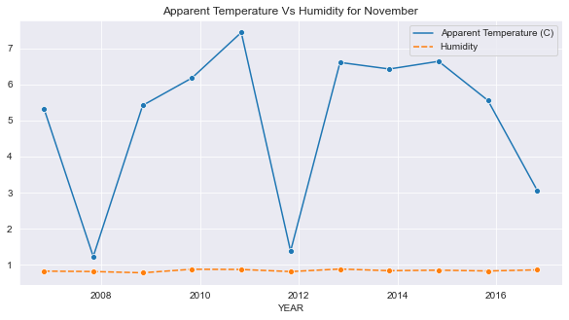

--------------------------------------------------------------------------------

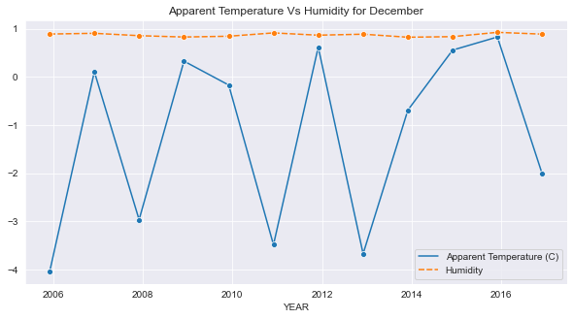

--------------------------------------------------------------------------------

Conclusion:

As we can see in the above images, there are many ups and downs in the temperature and the average humidity has remained constant throughout the 10 years.So, We can conclude that global warming has caused an uncertainty in the temperature over the past 10 years.